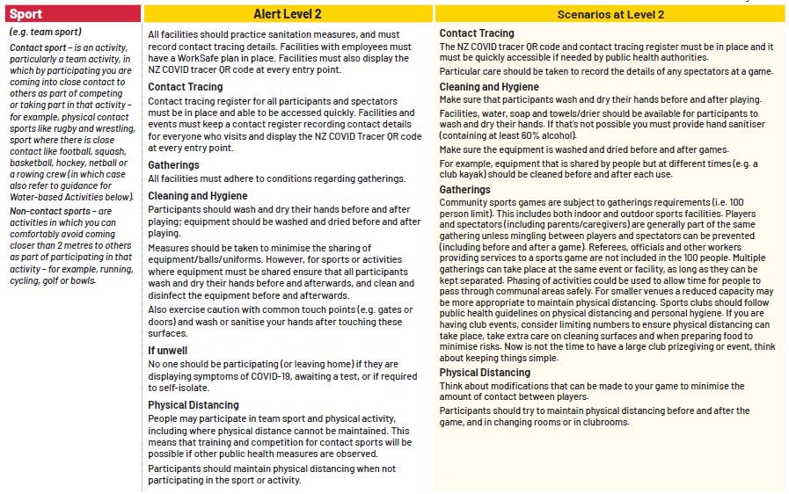

AREA TO MANAGE | HAZARD | RESPONSIBILITY | HEALTH AND SAFETY MEASURES
Contact Tracing | Entry Points  Tracking Teams  Tracking Spectators | Taupo AFC  Team Coaches/Manager | Every person to ‘scan in’ using the NZ government covid19 contact tracer app  Have a form available for people to fill out their details if they are unable to use the NZ government covid19 contact tracer app.  Team Coaches & Managers will complete team lists of those that have attended any trainings/games.
Players/Staff/ Spectators | Social distancing  Hygiene | Taupo AFC  Coaches/Managers | Everyone to wear a mask when inside the clubrooms  Players/Coaches/Spectators to wear a mask while arriving/leaving training. Mask can be removed while training.  Keep spectators to a minimum or ask not to attend for now
Changing rooms/Showers | Social distancing  Hygiene | Taupo AFC | Place signage reminding people of social distancing rules.  Limit the number of people allowed in the showers.  Only every second shower can be used.  Every shower has to be cleaned/sanitized after use.  Have cleaning products/sanitizer available for use of cleaning the shower when finished.  The whole changing room/showers needs to be cleaned/sanitized after use.
Bathrooms | Hygiene | Taupo AFC | Hand soap will be available in all bathrooms.  Paper towels will be available in all bathrooms.  Only 1 person per stall is permitted in the bathrooms at any given time.  Signage to be put on the doors and every hand basin.
Equipment | Ball Pump  Goals  Nets  Match Balls  Training balls  Flags  Stakes  Chairs  Dugout ‘walls | Taupo AFC  Coach/Manager | Ball pump to be sanitized after use  Goals to be sanitized at the end of every training/game.  Nets, flags, stakes, dugout walls to be sanitized after every training/game.  Match balls are to be sanitized prior to every match along with all players using sanitizer prior to taking the pitch.  All training balls to be sanitized after every training/warm-up.  Chairs are not to be used in the dugouts.
AREA TO MANAGE | HAZARD | RESPONSIBILITY | HEALTH AND SAFETY MEASURES
Referees room | Social distancing  hygiene | Taupo AFC | No more than 4 people at a time permitted.  Hand sanitizer to be used before entering and upon leaving.  All surfaces to be cleaned between games.
Bar | Social Distancing  Staff Safety  Hygiene | Taupo AFC  Bar Manager | Signage to inform public that no more than permitted amount of people allowed in clubrooms at any given time and to wait outside until allowed in.  Wipe down bar surfaces minimum of every 30 minutes.  Wipe down eftpos machines after every use.  Discourage social gatherings.  Keep access to the clubrooms clear.
Clubroom Social spaces | Social distancing | Taupo AFC  Bar Manager | Signage to inform public that no more than permitted amount of people allowed in clubrooms at any given time.  No after match functions permitted inside of the clubrooms.  Discourage social gatherings.  Keep access to the clubrooms clear.
Shelters | Social distancing | Taupo AFC | Place signage reminding public of social distancing rules.

